**WATER LEVEL MANAGEMENT**

**EX:** 3

**DATE:**09/07/2024

**AIM:**

To perform Water Level Management using Ultrasonic Sensor and bluetooth HC 05.

**PROCEDURE:**

**STEP 1:** Connect the HC-05 to the Arduino: VCC on HC-05 to 5V on Arduino,GND on HC-05 to GND on Arduino,TXD on HC-05 to RX on Arduino RXD on HC-05 to TX on Arduino.

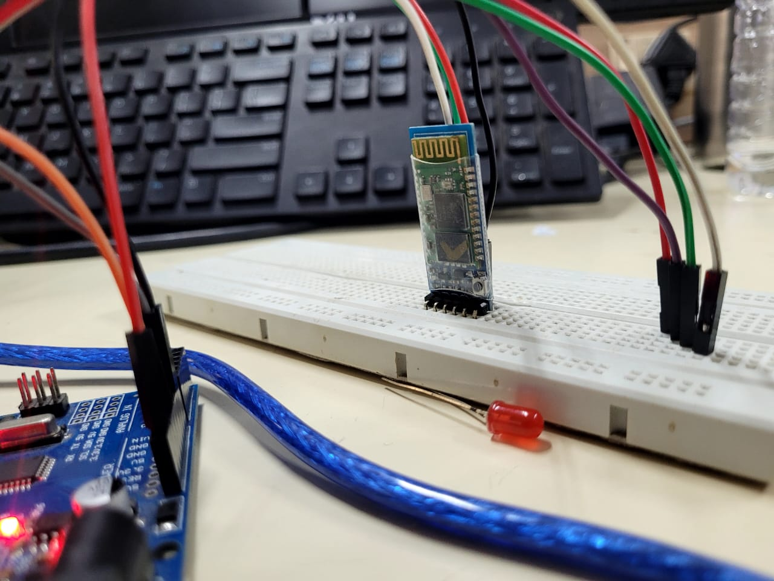

**STEP 2:** HC-SR04 Ultrasonic Sensor VCC: Connect to 5V on the Arduino GND: Connect to GND on the Arduino Trig: Connect to Digital Pin 9 on the Arduino Echo: Connect to Digital Pin 10 on the Arduino

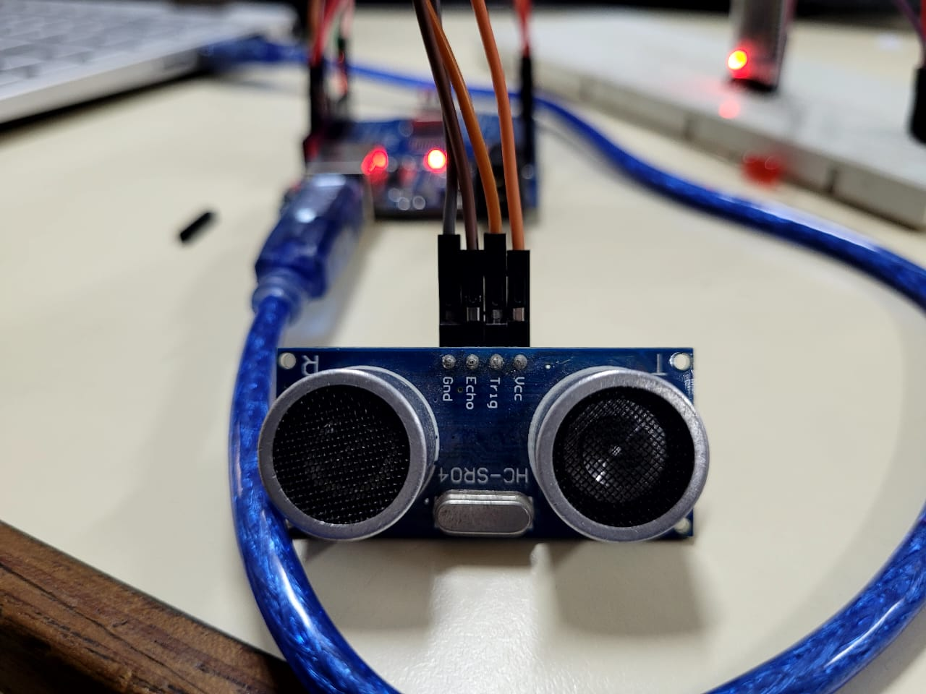

**STEP 3:** Upload sketch to read the distance from the ultrasonic sensor and send alerts via Bluetooth

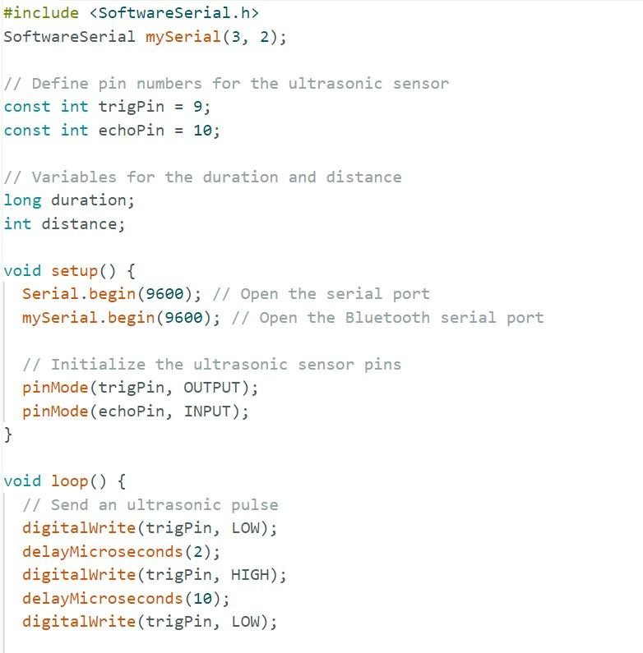

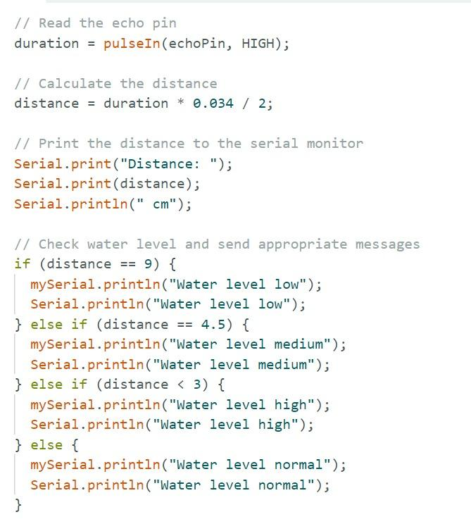

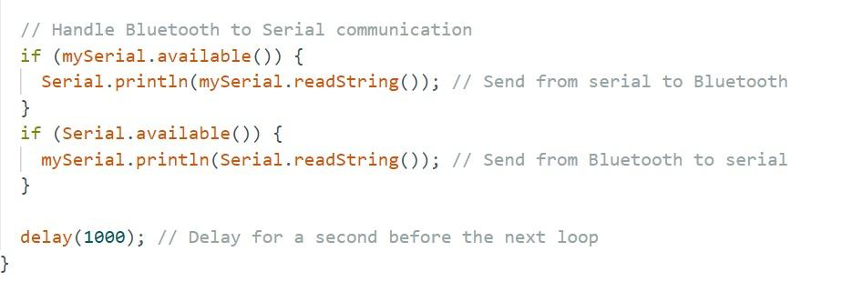

### **STEP 4:**Pair HC-05 with a Device Power on the Arduino: Ensure the HC-05 module is also powered.Enable Bluetooth: On your smartphone or computer, go to Bluetooth settings.Scan for devices: Look for "HC-05" and pair with it. The default pairing code is "1234"

**STEP 5:**Testing Communication The Arduino will measure the water level using the ultrasonic sensor.The distance will be displayed on the Serial Monitor and sent via Bluetooth to the paired deviceOpen a Bluetooth terminal app on your paired smartphone or computer.The distance measurements will be sent to the Bluetooth terminal.

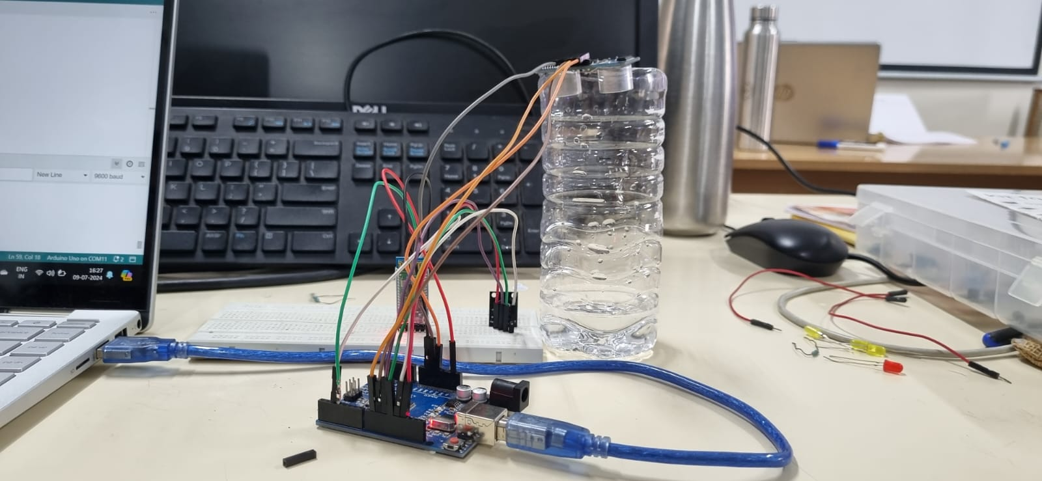

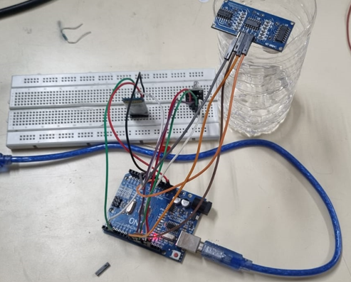

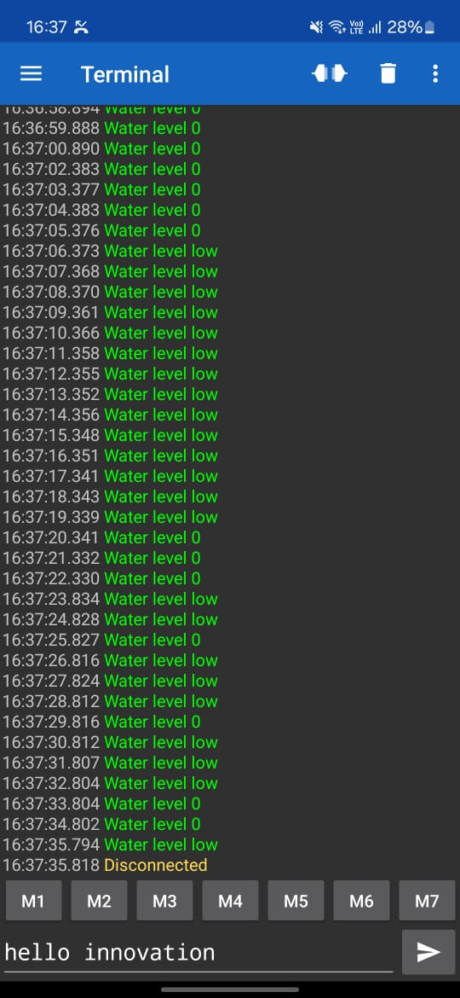

**RESULT:**

ThusWater Level Management using Ultrasonic Sensor and bluetooth HC 05 has been performed successfully

**AUTHORIZATION MANAGEMENT USING NODE MCU AND RFID**

EX NO: 4

DATE:19.07.2024

**AIM:**

To implement the user authentication using RFID and Arduino uno.

**RFID :**

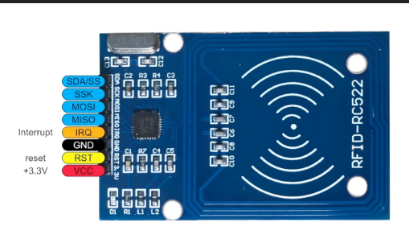 The RFID card reader also has a coil of copper wire. This coil creates a magnetic field when a current flows through it. When the RFID card is placed near the card reader, the magnetic field from the card reader induces a current in the card’s wire coil. This current is enough to power the card’s onboard IC. The card reader can then read the unique identification number on the card.

**MATERIALS REQUIRED :**

1.RFID reader mmodule

2.Arduino uno

3.Jumpers

**USER AUTHENTICATION USING RFID**

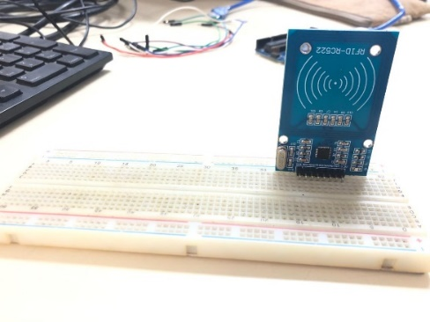**STEP 1** : Place the RFID reader module on the breadboard as shown below.

Figure 1.Placement of RFID reader

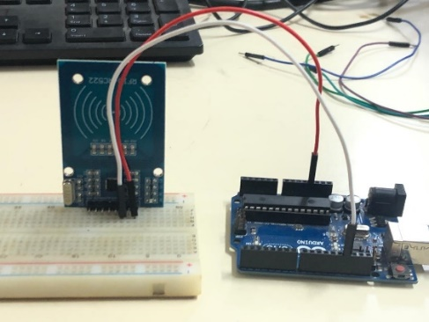**STEP 2**: Connect the voltage and ground pins of the RFID module to the Vcc and GND of Arduino uno.

Figure 2.Vcc and GND connection

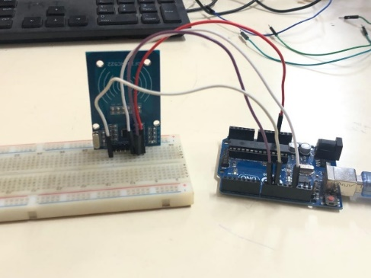**STEP 3:** Configure the Reset pin and SCK pinout to any input pins(8,9) of the Arduino uno.

Figure 3.RST and SCK connection

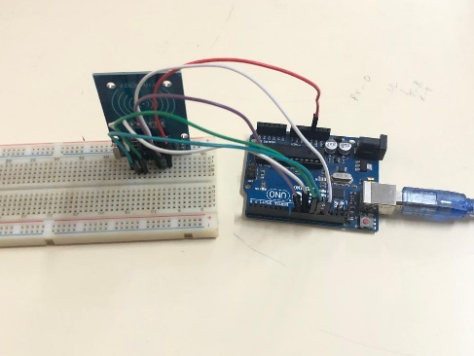**STEP 4:** Connect the MISO and MOSI pins to any input pins of Arduino uno.

Figure 4.MISO and MOSI connection

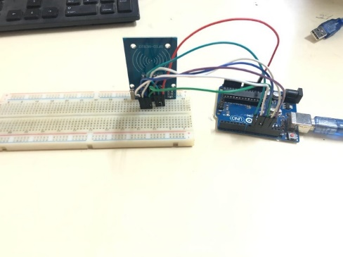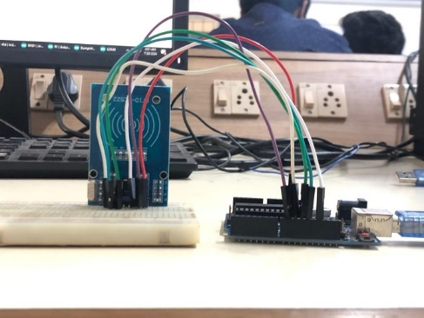**STEP 5 :** Configure the SDA pinout of RFID reader to the input pin of Arduino uno.

Figure 5.1 SDA connection Figure 5.2 Complete connection

**STEP 6:** Upload the code to the Arduino uno and check for the tag id in the serial monitor.

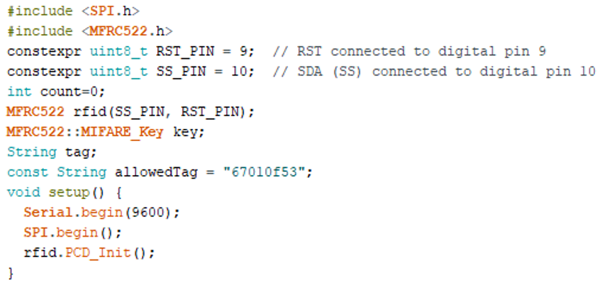**PROGRAM :**

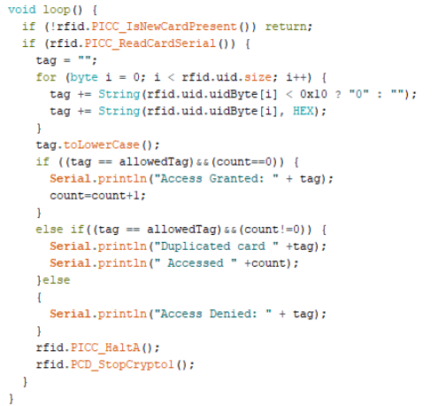

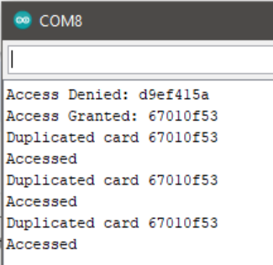**OUTPUT:**

**RESULT :**

Thus the using RFID reader module and Arduino uno ,the user authentication has been successfully implemented.

Ex no:5 **WEATHER MONITORING USING DHT11**

Date : 02.08.2024

**AIM:**

To monitor the real time temperature and humidity using DHT11 sensor and Arduino uno.

**DHT11 :**

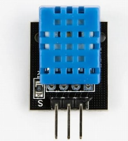 DHT11 is a low-cost digital sensor for sensing temperature and humidity.  This sensor can be easily interfaced with any micro-controller such as Arduino, Raspberry Pi etc… to measure humidity and temperature instantaneously.

**MATERIALS REQUIRED :**

1.DHT11 sensor

2.Arduino uno

3.Jumpers

4.Bluetooth module

**TEMPERATURE AND HUMIDITY MONITORING**

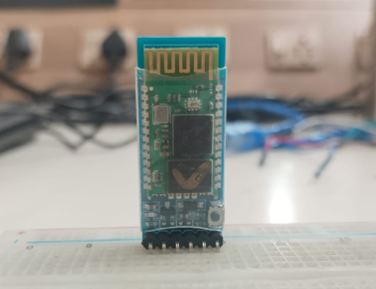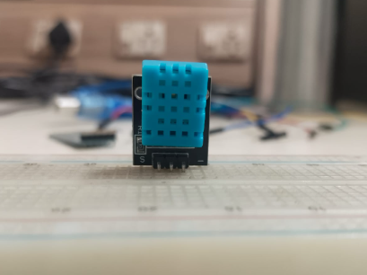 **STEP 1** : Place the DHT11 sensor and bluetooth module on the breadboard as shown below.

Figure 1.Placement of DHT11 sensor Figure 1.2 Placement of Bluetooth module

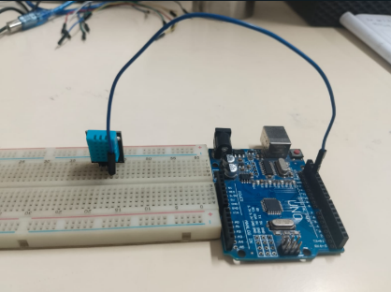**STEP 2**: Connect the ground pin of the DHT11 sensor to GND of Arduino uno.

Figure 2. GND connection of DHT11

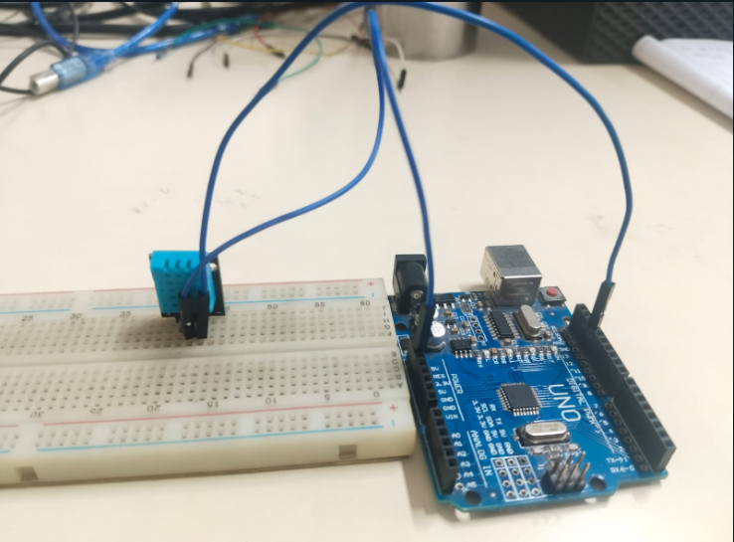**STEP 3:** Connect the voltage pin of the DHT11 sensor to Vcc of Arduino uno.

Figure 3.Vcc connection of DHT11

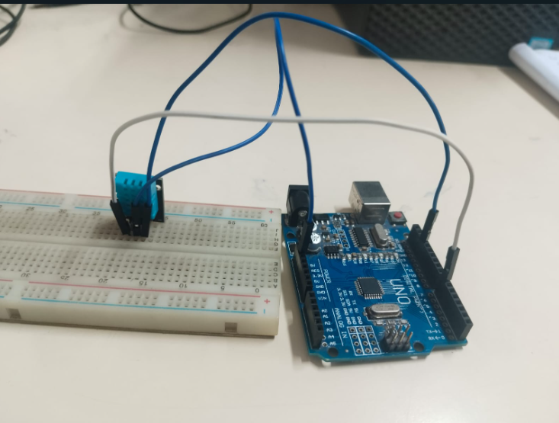 **STEP 4:** Connect the input pins of DHT11 sensor to any input pins of Arduino uno.

Figure 4.Input pin of DHT11

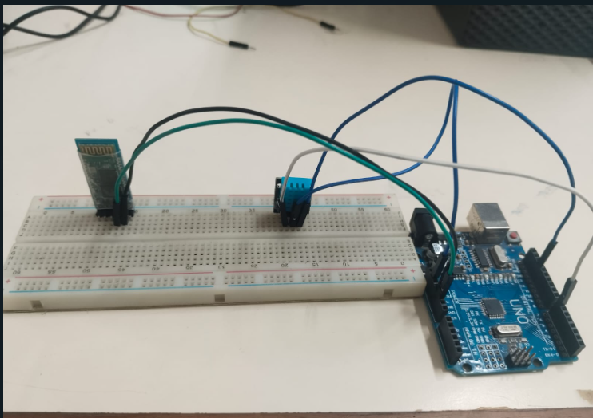**STEP 5 :** Connect the voltage and ground pins of Bluetooth to the Arduino uno.

Figure 5.Vcc and GND connection of HC-05

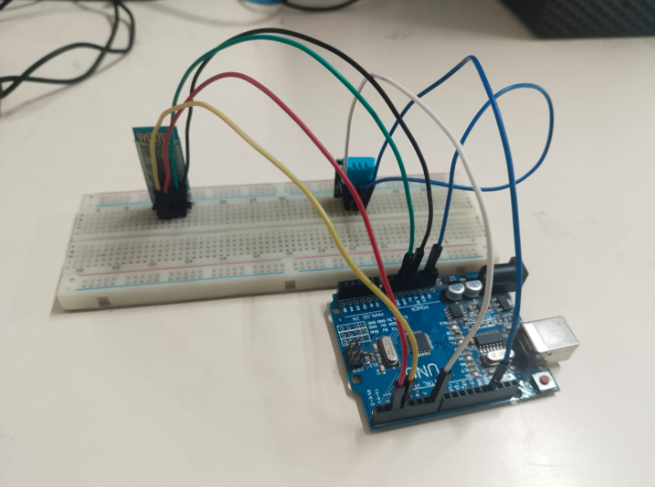**STEP 6:** Connect the transmission and receiver pins of HC-05 module to the input pins of Arduino uno.

Figure 6.Tx and Rx connection of HC-05

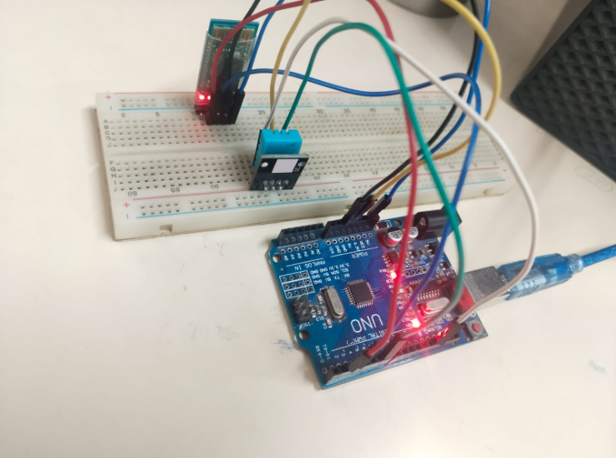**STEP 7:** Upload the code and infer the output in the serial monitor

Figure 7.Complete connection

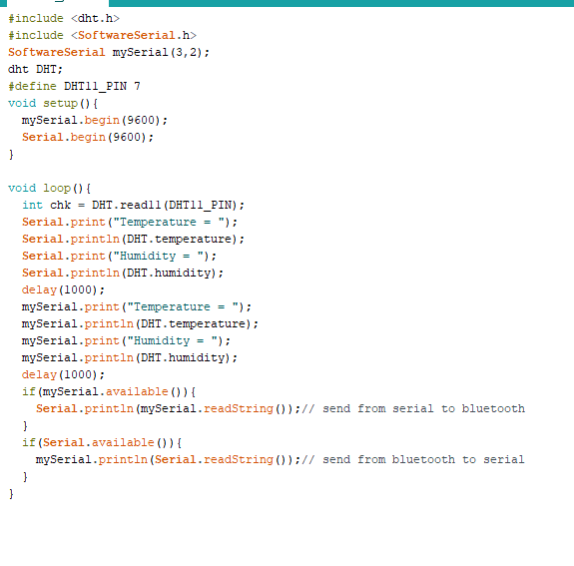**PROGRAM :**

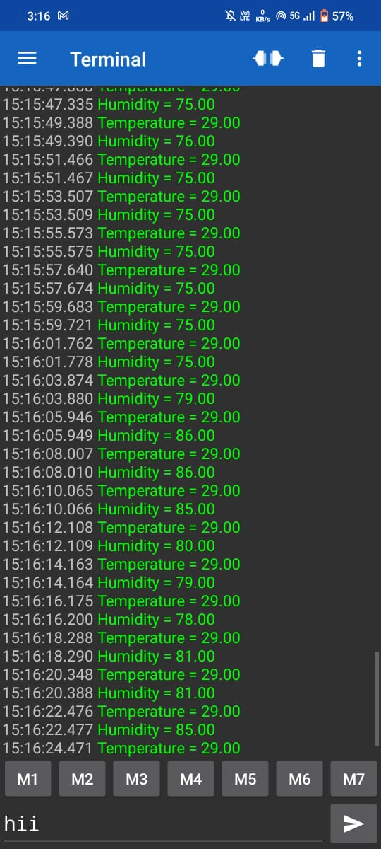**OUTPUT:**

**RESULT :**

Thus the real time temperature and humidity has been monitored and send to the user’s local device using DHT11 and Bluetooth module.

**DATA RETRIVAL AND VISUALIZATION USING THINGSPEAK**

**EX NO: 6 DATE: 06/09/2024**

**AIM:**

To connect Node MCU with thingspeak to show the graph plot for collected readings from ultrasonic sensor.

**REQUIRED COMPONENTS:**

* Node MUC
* Breadboard
* Jumpers as required
* Ultrasonic sensor
* WIFI router

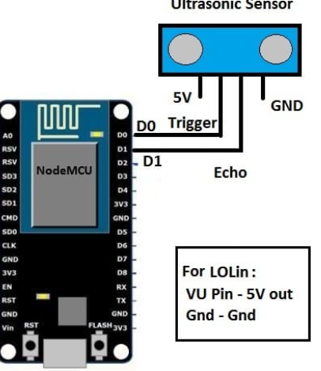

**PINOUT TABLE:**

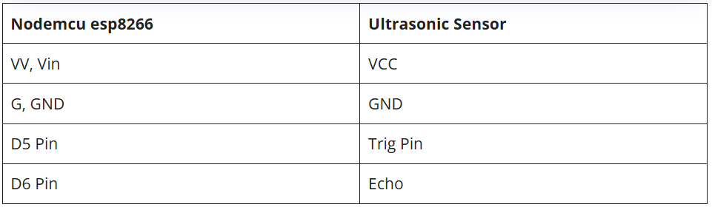

**Fig.1**

**Fig.2**

**PROCEDURE:**

* The HC-SR04 ultrasonic sensor has four pins out of which two are used to provide power to the sensor and the other two are for the data.
* Connect the VCC pin of the ultrasonic sensor to the VIN pin of the nodemcu.
* Join the GND pin of the ultrasonic sensor with the GND pin of the nodemcu.
* Connect the TRIG and ECHO pins of the ultrasonic sensor with the digital-5 and digital-6 pins of the nodemcu as shown above in the diagram.
* Now connect the USB cable to the nodemcu so that the ultrasonic sensor starts working and you can see the values on the serial monitor screen.
* **Setting Up ThingSpeak:**

1. **Create a Channel:**
   * Sign in to ThingSpeak.
   * Create a new channel and note down the **Channel ID** and **Write API Key**.

**CREATING SKETCH:**

#include <ESP8266WiFi.h>

#include <WiFiClient.h>

#include <ESP8266HTTPClient.h>

const char* ssid = "YOUR_SSID"; // Your Wi-Fi SSID

const char* password = "YOUR_PASSWORD"; // Your Wi-Fi Password

const char* thingSpeakHost = "api.thingspeak.com";

const String apiKey = "YOUR_WRITE_API_KEY"; // Your ThingSpeak Write API Key

const int trigPin = D1; // Trigger pin

const int echoPin = D2; // Echo pin

void setup() {

Serial.begin(115200);

pinMode(trigPin, OUTPUT);

pinMode(echoPin, INPUT);

WiFi.begin(ssid, password);

while (WiFi.status() != WL_CONNECTED) {

delay(1000);

Serial.println("Connecting to WiFi...");

}

Serial.println("Connected to WiFi");

}

void loop() {

long duration, distance;

// Trigger the sensor

digitalWrite(trigPin, LOW);

delayMicroseconds(2);

digitalWrite(trigPin, HIGH);

delayMicroseconds(10);

digitalWrite(trigPin, LOW);

// Read the echo pin

duration = pulseIn(echoPin, HIGH);

distance = (duration * 0.034) / 2; // Calculate distance in cm

// Print distance

Serial.print("Distance: ");

Serial.println(distance);

// Send data to ThingSpeak

if (WiFi.status() == WL_CONNECTED) {

WiFiClient client;

HTTPClient http;

String url = String("http://") + thingSpeakHost + "/update?api_key=" + apiKey + "&field1=" + String(distance);

http.begin(client, url);

int httpResponseCode = http.GET();

if (httpResponseCode > 0) {

String response = http.getString();

Serial.println(httpResponseCode);

Serial.println(response);

} else {

Serial.print("Error on HTTP request: ");

Serial.println(httpResponseCode);

}

http.end();

}

delay(20000); // Update every 20 seconds

}

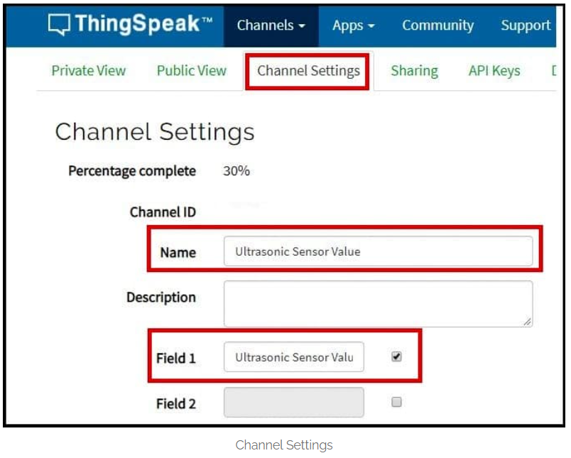

**Fig.3**

* To channel settings and name it as “Ultrasonic Sensor Value” and select field

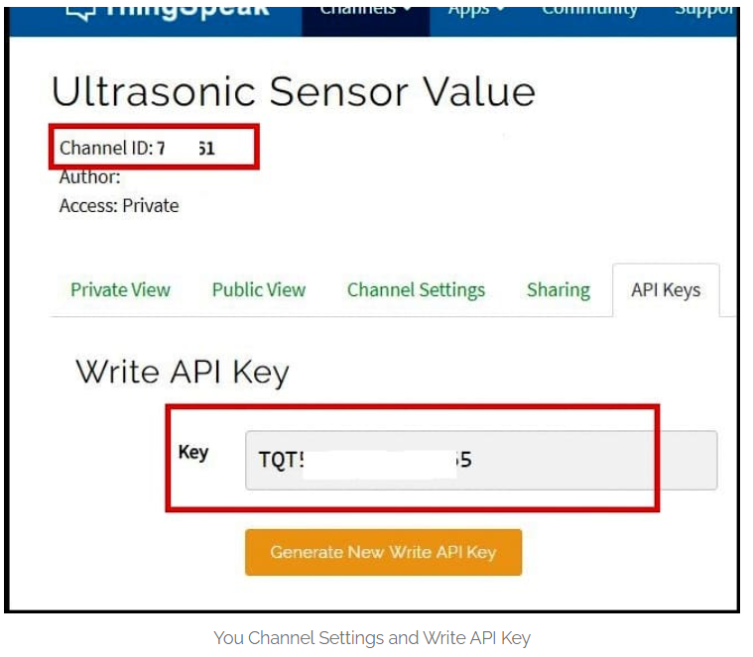

**Fig.4**

* After uploading this code to Node MCU, open the serial monitor at **115200 baudrate** to see the measurement and open your browser to see the incoming data on Thingspeak

**OUTPUT:**

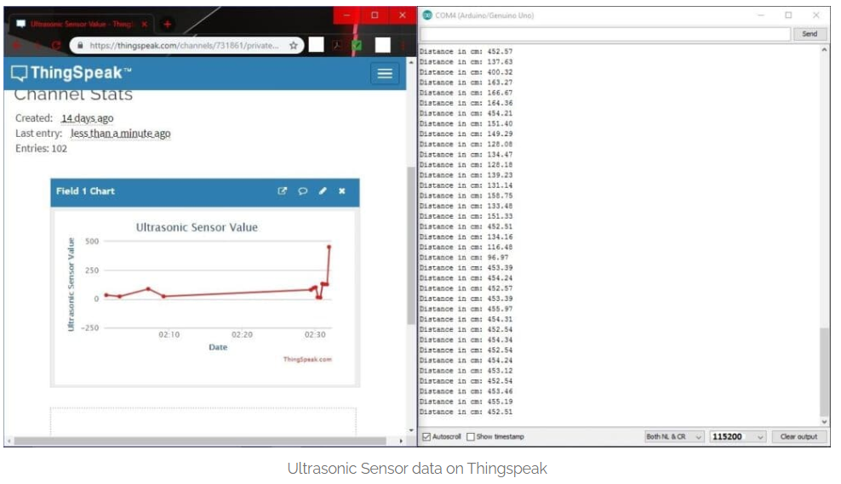

**Fig.5**

**RESULT:**

The Node MCU is successfully connected with ThingSpeak cloud and the data retrieved from ultrasonic sensor is send to ThingSpeak cloud, and the values are populated as a graph as shown in fig.5.

**STUDY ON RASPBERRY PI**

**Aim:**

To study on raspberry pi.

**Study:**

Raspberry Pi is a series of small, affordable single-board computers developed by the Raspberry Pi Foundation, primarily aimed at promoting computer science education. Since its inception, it has gained immense popularity among hobbyists, educators, and professionals for a wide range of applications. The flexibility and cost-effectiveness of Raspberry Pi make it an attractive option for learning programming, developing projects, and prototyping innovative ideas. The Raspberry Pi lineup includes several models, each with varying specifications to suit different needs. Key features include a powerful CPU that ranges from 700 MHz in the original Pi to 1.5 GHz in the latest models, and memory options that vary from 512 MB to 8 GB of RAM. With connectivity options like USB ports, HDMI, Ethernet, Wi-Fi, and Bluetooth, Raspberry Pi can easily integrate with various peripherals and networks. Additionally, its GPIO (General Purpose Input/Output) pins allow users to interface with a multitude of hardware components, making it a favourite for DIY electronics projects.

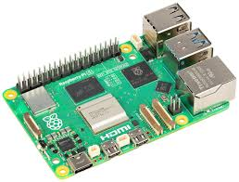

Fig 8.1 Raspberry pi

Raspberry Pi has found diverse applications across education, industry, and personal projects. In educational settings, it serves as a practical tool for teaching programming and electronics, offering hands-on experience that fosters creativity and problem-solving. In the industrial realm, it is used for IoT device prototyping, automation, and data collection, showcasing its versatility. For hobbyists, Raspberry Pi enables projects like home automation systems, media centres, and retro gaming consoles, further demonstrating its capability to cater to various interests. The robust Raspberry Pi community provides extensive resources, including forums, tutorials, and documentation, fostering collaboration and knowledge-sharing among users. As technology continues to evolve, the Raspberry Pi Foundation is likely to enhance its offerings, focusing on improved performance, support for artificial intelligence, and cloud integration for IoT projects. This evolution positions Raspberry Pi not only as a tool for education and hobby but also as a significant player in future technological advancements.

**RESULT:**

Thus, the study on raspberry pi has been done.

**REAL TIME SURVELLIANCE USING RASPBERRY PI**

**EX. NO: 7 DATE: 13/09/2024**

**AIM:**

To connect Raspberry Pi with camera module to obtain the photo of real time objects.

**REQUIRED COMPONENTS:**

* Raspberry PI
* Breadboard
* Jumpers as required
* Camera Module
* LCD Display

**PINOUT TABLE:**

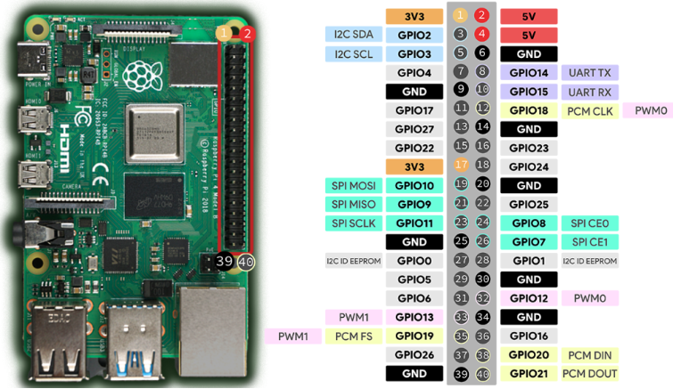

**Fig.1**

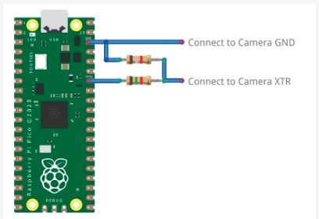

**Fig.2**

**PROCEDURE:**

• **Prepare the Hardware:**

* **Power Off:** Ensure your Raspberry Pi is powered off.
* **Connect the Camera Module:**
  + Locate the camera connector (CSI port) on the Raspberry Pi.
  + Gently lift the plastic latch on the connector.
  + Insert the camera module’s ribbon cable (blue side facing the HDMI port).
  + Push the latch back down to secure the cable.

• **Power On the Raspberry Pi:**

* Connect the power supply and turn on the Raspberry Pi.

• **Enable Camera Support:**

* Open a terminal window.
* Run sudo raspi-config.
* Navigate to **Interfacing Options** > **Camera**.
* Enable the camera interface.
* Exit the configuration tool and allow the Raspberry Pi to reboot.

**CREATING SKETCH:**

**Install Required Packages:**

sudo apt update

sudo apt upgrade

**Install the camera tools:**

sudo apt install python3-picamera

**Test the Camera:**

raspistill -o test.jpg

**Code for capturing an image:**

from picamera2 import PiCamera2.Preview

from time import sleep

# Create an instance of the PiCamera

camera = PiCamera2()

#Configure the camera

camera_config=camera.create_preview_configuration()

camera.configure(camera_config)

# Start the camera preview

camera.start_preview()

# Allow time for the camera to adjust

sleep(2)

# Capture an image

camera.capture('/home/pi/Desktop/image.jpg')

# Stop the preview

camera.stop_preview()

print("Image captured and saved as image.jpg")

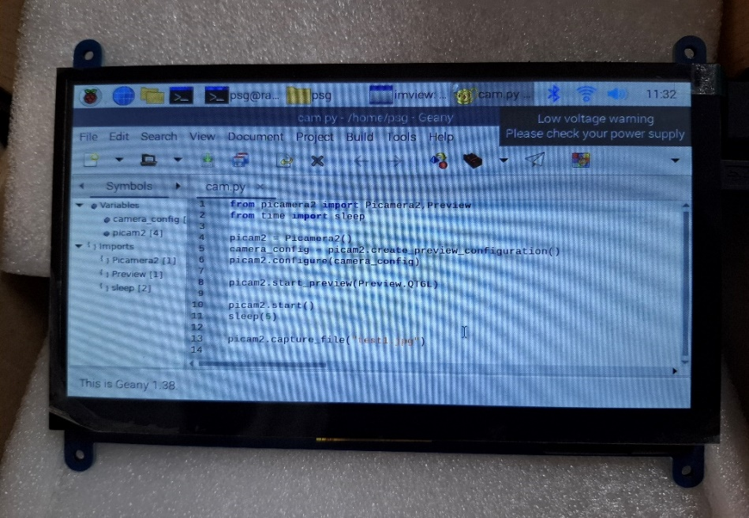

**Fig.3**

* LCD display containing the sketch for the camera module.

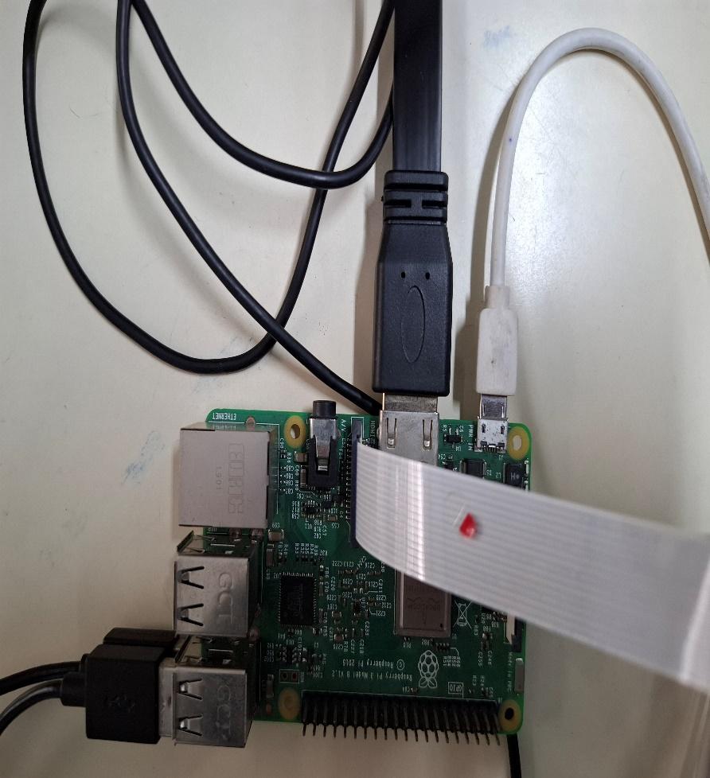

**Fig.4**

**OUTPUT:**

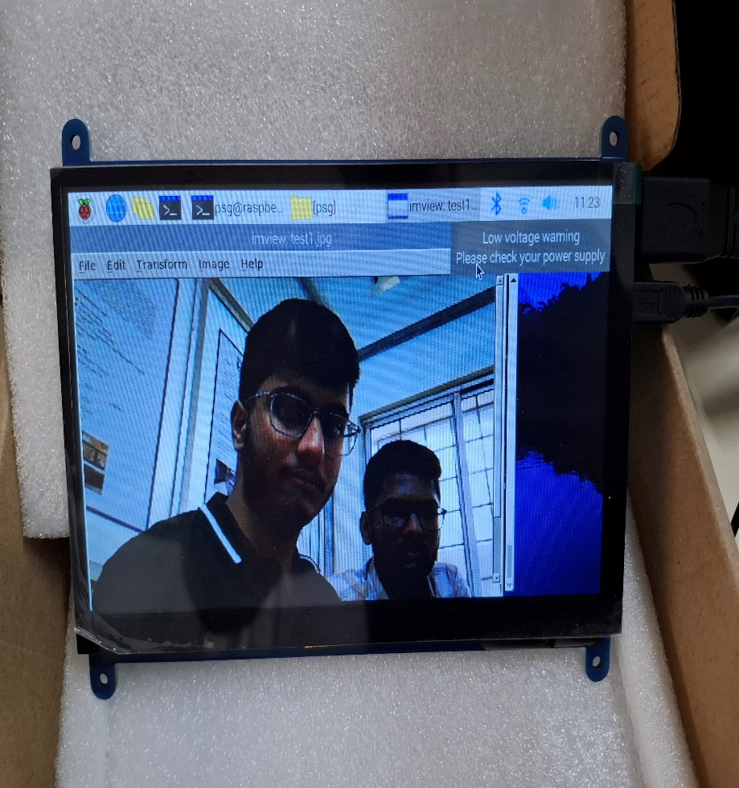

**Fig.5**

**RESULT:**

The Raspberry PI is connected with the camera module and the photo is captured successfully as shown in fig.5.

**EDGE AND FOG FOR IOT**

**EX. NO: 8 DATE:06.09.2024**

**INTRODUCTION**

Node-RED is a powerful tool for wiring together hardware devices, APIs, and online services. This report outlines the steps to install Node-RED, the necessary Java and other requirements, and how to display the distance measured by an ultrasonic sensor.

**PREREQUISITES**

**1. Hardware Requirements**

* **Ultrasonic Sensor** (e.g., HC-SR04)
* **Microcontroller** (e.g., Raspberry Pi, Arduino)
* **Jumper Wires**
* **Breadboard** (optional)

**2. Software Requirements**

* **Node.js** (recommended version: 14.x or later)
* **npm** (Node Package Manager)
* **Java** (if required for specific integrations)

**INSTALLATION STEPS**

**Step 1: Install Node.js**

1. **Update System Packages** (for Linux):

bash

Copy code

sudo apt update

sudo apt upgrade

1. **Install Node.js**: For Debian-based systems (like Raspberry Pi OS):

bash

Copy code

curl -fsSL https://deb.nodesource.com/setup_14.x | sudo -E bash -

sudo apt-get install -y nodejs

1. **Verify Installation**:

bash

Copy code

node -v

npm -v

**Step 2: Install Node-RED**

1. **Install Node-RED**:

bash

Copy code

sudo npm install -g --unsafe-perm node-red

1. **Start Node-RED**:

bash

Copy code

node-red

1. **Access Node-RED**: Open a web browser and navigate to http://localhost:1880.

**Step 3: Install Java (if required)**

If your application requires Java (e.g., for specific nodes or integrations):

1. **Install Java**:

bash

Copy code

sudo apt install default-jdk

1. **Verify Installation**:

bash

Copy code

java -version

**CONNECTING THE ULTRASONIC SENSOR**

**Step 1: Wiring the Ultrasonic Sensor**

Connect the HC-SR04 ultrasonic sensor to the microcontroller as follows:

| **HC-SR04 Pin** | **Microcontroller Pin** |
| --- | --- |
| VCC | 5V |
| Trig | GPIO Pin (e.g., 18) |
| Echo | GPIO Pin (e.g., 24) |
| GND | GND |

**Step 2: Setting Up the Microcontroller**

1. **Install Required Libraries** (e.g., for Raspberry Pi):

bash

Copy code

sudo apt install python3-rpi.gpio

1. **Create a Python Script**: This script will read data from the ultrasonic sensor.

python

Copy code

import RPi.GPIO as GPIO

import time

# Set GPIO mode

GPIO.setmode(GPIO.BCM)

# Define GPIO pins

TRIG = 18

ECHO = 24

GPIO.setup(TRIG, GPIO.OUT)

GPIO.setup(ECHO, GPIO.IN)

def measure_distance():

GPIO.output(TRIG, True)

time.sleep(0.01)

GPIO.output(TRIG, False)

while GPIO.input(ECHO) == 0:

start_time = time.time()

while GPIO.input(ECHO) == 1:

end_time = time.time()

duration = end_time - start_time

distance = (duration * 34300) / 2

return distance

try:

while True:

distance = measure_distance()

print(f"Distance: {distance:.2f} cm")

time.sleep(1)

except KeyboardInterrupt:

GPIO.cleanup()

1. **Run the Python Script**:

bash

Copy code

python3 your_script.py

**Step 3: Integrate with Node-RED**

**Step 1: Install Node-RED Node for Raspberry Pi GPIO**

1. **Open Node-RED**: Navigate to http://localhost:1880.
2. **Install node-red-node-pi-gpio**: In the Node-RED interface, open the menu, select "Manage palette," and install node-red-node-pi-gpio.

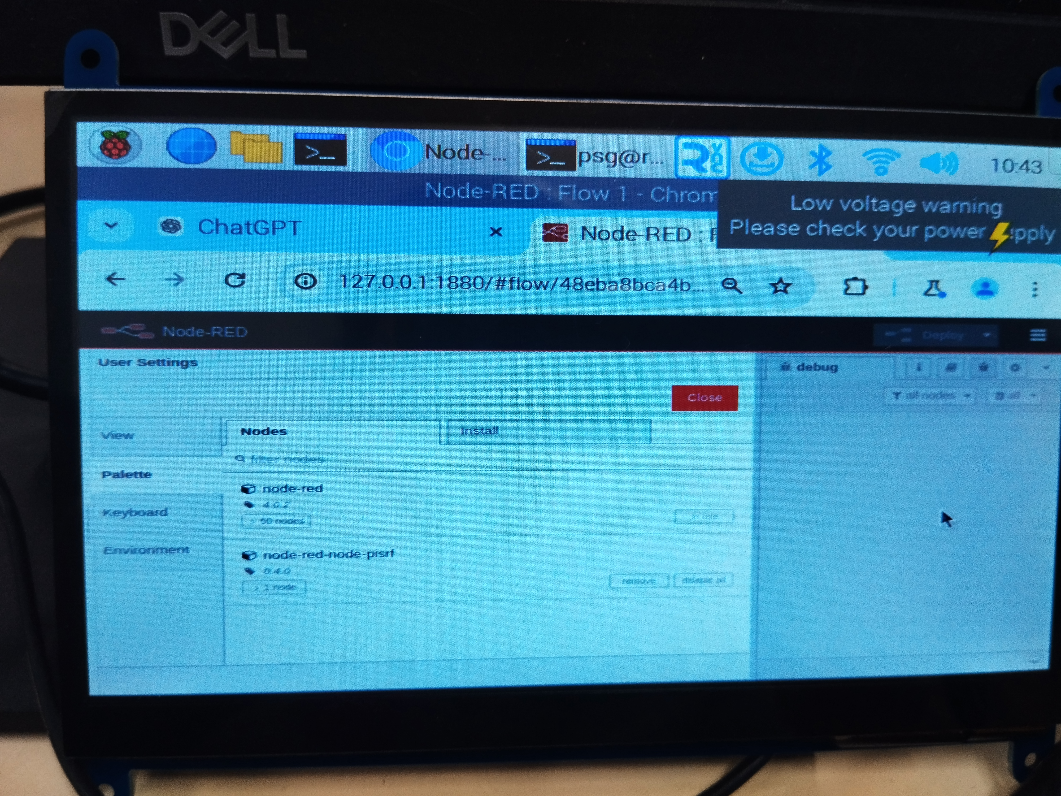

**Step 2: Create a Flow to Read Distance**

1. **Add Nodes**:
   * **Inject Node**: To trigger the measurement.
   * **Function Node**: To format the data.
   * **Debug Node**: To display the output.
   * **Notification Node**: To pop up notification in the dashboard.
2. **Configure the Inject Node**: Set it to trigger at intervals (e.g., every second).
3. **Configure the Function Node**: Use the following code to read from the Python script:

javascript

Copy code

msg.payload = execSync('python3 /path/to/your_script.py').toString();

return msg;

1. **Connect Nodes**: Wire the nodes together.
2. **Deploy the Flow**: Click on the "Deploy" button.

**Step 3: View Distance in Node-RED**

* Open the Debug sidebar in Node-RED to see the distance readings displayed.

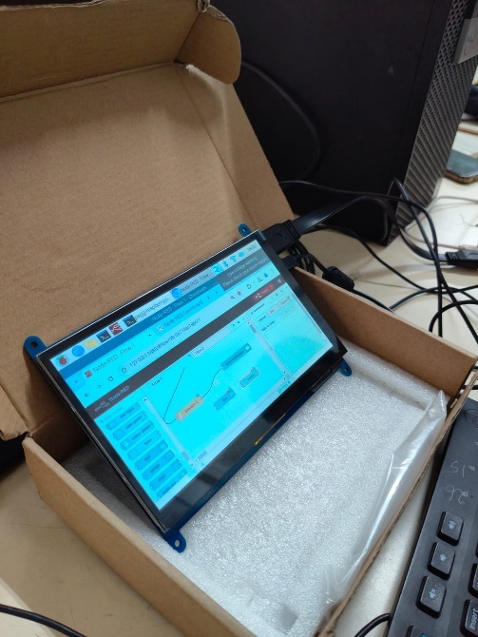

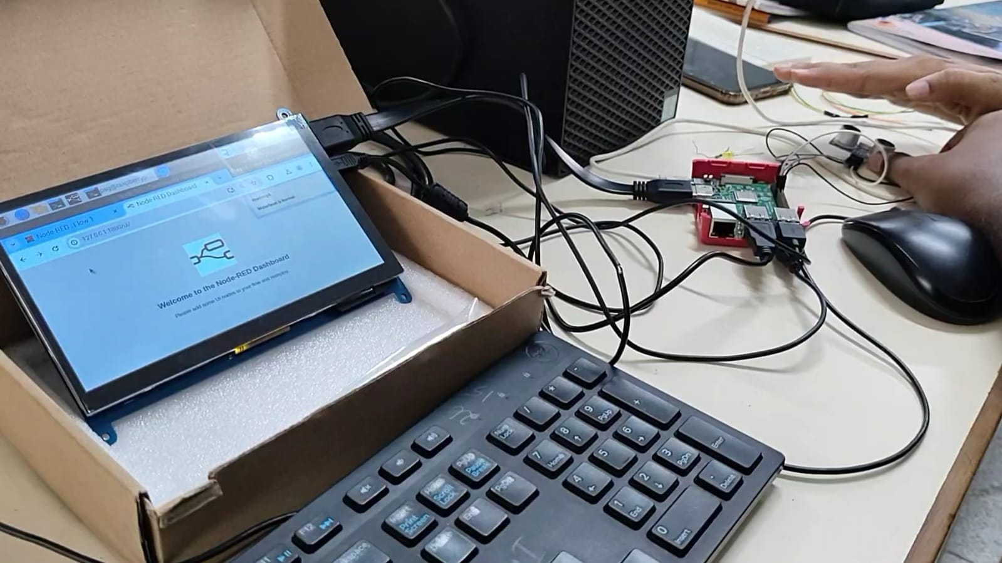

**CONCLUSION**

This report provides a comprehensive guide on setting up Node-RED to read and display distance data from an ultrasonic sensor as well as provide pop notification to the user as an alert message in the dasboard. By following these steps, users can effectively integrate hardware with Node-RED, facilitating IoT development and automation tasks.

For further enhancements, consider adding visual elements, logging data, or integrating with other services.